Seabird Monitoring & Research Project

Isles of Scilly 2024

Hester Odgers, Vickie Heaney, Becky Hodgekiss

# Summary of Seabird Monitoring and Research 2024

Following last summer’s SPA survey, the 2024 seabird monitoring program returned to the regular annual monitoring of a sample of sites and breeding seabird species across Scilly, with additional monitoring carried out through funding provided by Natural England through Defra marine Natural Capital and Ecosystem Assessment (mNCEA) programme.

This season was unusual in the number of external and partnership projects focused on Scilly’s breeding seabirds, including:

* + University of Exeter Forage Fish PhD: aims to map the distribution and interactions of seabirds and fish species in the Isles of Scilly and the role of seabirds in local nutrient enrichment.
  + RSPB storm petrel tracking project: aims to track the foraging trips of adult storm petrels nesting on Scilly.
  + The re-starting of the Scillonia Seabird Ringing Group with help from the West Cornwall Ringing Group.

**Annet (main annual sample site for the majority of species)**

* Great black-backed gulls have continued to decline since 2019 (now 138 AON, down from 151 AON in 2023).
* The shag population has slightly recovered since last year’s record low of 53 AON, up to 88 AON this year.
* 11 Common tern pairs nested (the first year they are known to have nested here since 2021), but the breeding success was unknown.
* Fulmars have continued to decline, with the population now at its lowest recorded level (30 AON) since 2000.
* The storm petrel population at our regular study beach was an estimated 29 AON, a drop of 80% from 2022’s estimate of 132 AON.
* Juvenile storm petrels on Annet were observed ‘star gazing’ in a similar manner to Manx shearwater chicks during an overnight ringing trip to Annet on 31st August-1st September.

**St Agnes & Gugh**

* Have been rat-free since 2014.
  + The lesser black backed gull colony on Gugh remains reasonably stable at around 423 AON.
  + There was a drop in Manx shearwater numbers (from 199 AON in 2023 to 154 AON in 2024), but this is largely due to the fact that the response rate calibration factor for Manx shearwaters (calculated from the calibration survey on St Agnes) is significantly higher (0.67) than that calculated in 2023, resulting in lowered estimates of the Manx shearwater population across Scilly. Successful breeding was recorded on both islands, but full chick counts were not carried out.
* Storm petrel playback survey carried out at Burnt Island, St Agnes, suggests the population of around 40 remains stable since 2023.
* The kittiwake colony on produced 11 fledged chicks from 22 nests, the highest productivity seen at this colony since 2010.
* Despite one scare (a dead storm petrel found at St Agnes campsite), there was no confirmed evidence of predation by cats.

**Round Island & St Helen’s**

* + Storm petrel counts from Round Island are down from 105 AON last year to 17 AON this year. This is thought to be due to a rat incursion that occurred at some point between August and December 2024 (the island was subsequently re-cleared of rats).
  + There was a drop in estimated Manx Shearwater population of Round Island from 96 AON in 2023 to 62 AON 2024, but this is again partially due to the low correction factor used for all Manx shearwater surveys on Scilly this year.
  + A survey of the Manx shearwater population of St Helen’s found an estimated 89 pairs, and it is not known whether any chick were successfully fledged (given the rat population was dramatically reduced over winter during an attempted eradication, but not eradicated).

**Other productivity**

* Fulmars on two sub-colonies (Menawethan and the Daymark), showed productivity is at its lowest since 2021 (at 0.11 and 0.18 respectively). The recent low productivity levels possibly partly explain the drop in breeding population of 16% since 2015 across Scilly.
* Herring gull productivity in the Hugh Town colony remains reasonably stable, albeit with a slight drop to 1.35 in 2024 from 1.78 in 2023

# Introduction

This report summarises the results of seabird fieldwork conducted between April and October 2024, undertaken by the Isles of Scilly Wildlife Trust, funded through Natural England’s Marine Natural Capital and Ecosystem Assessment (mNCEA) programme. Scilly's seabird breeding records comprise one of the best long-term environmental data sets we have for the islands; this report adds to the annual productivity data for key seabird species collected at key sites across the islands since 2006. Productivity for the species recorded here were collected using standard methods as set out in *The Seabird Monitoring Handbook* (Walsh *et al*. 1995). In 2024, Natural England added the Isles of Scilly Special Protection Area to the list of proposed English Key Sites for the Seabird Monitoring Program, along with the Flamborough and Filey Coast SPA, and the Farne Islands SPA. The inclusion as a proposed key site came with the hope that IOSWT would put resource into collecting additional data on productivity and abundance of priority species where possible, as well as beginning a BTO RAS scheme to collect data on survival. Of particular interest was data on European shags, great black-backed gulls and lesser black-backed gulls. This was done primarily through camera work funded through Natural England’s Marine Natural Capital and Ecosystem Assessment (mNCEA) programme, and through the restarting of the Scillonia Ringing Group which has begun a BTO RAS scheme on all three species.

The data gathered helps to fill the gaps between the full Special Protection Area (SPA) counts of all the seabirds breeding across the Isles of Scilly, last conducted in 2023. This contributed to the data showing Scilly’s high species diversity count compared to other sites in England. 2023 surveys recorded over 8,000 pairs of 13 species of regularly breeding seabird. With internationally important numbers of lesser black-backed gull and storm petrel and nationally important numbers of great black-backed gull (possibly the largest colony in the UK), Manx shearwater and shag (the largest breeding colony in England), seabirds are a named feature in the SPA and many of the SSSI designations for the area and are a vitally important part of our Natural Heritage. The data collected in Scilly also contributes to national seabird records and allows comparison between different regional populations.

# Results

## Monitoring of seabird numbers and productivity on St Agnes and Gugh

A full survey of all seabird species breeding on St Agnes and Gugh has been conducted annually since 2012 as part of the long-term monitoring to assess the response to the removal of rats in the winter of 2013/14. The results from this and the three previous SPA counts are included in Tables 1 and 2 below. Over this period the number of both herring and lesser black-backed gulls has decreased, with the main lesser black-backed gull colony on Gugh dropping from 1132 pairs in 200 to 361 in 2012 before maintaining a relatively stable population of around 400 ever since. Herring gulls this year have been recorded at their lowest population count on St Agnes and Gugh since surveying began. Ringed plover were recorded breeding successfully at Beady Pool in 2022 and 2024 and the number of oystercatchers remained high across the two islands.

|  |  |  |  |  |  |  |  |  |  |  |  |  |  |  |
| --- | --- | --- | --- | --- | --- | --- | --- | --- | --- | --- | --- | --- | --- | --- |
|  | **FUL** | **MX** | | **SH** | | **LBBG** | **HG** | **GBBG** | **KIT** | **COT** | **SP** | **RPL** | **OYC** | **Total** |
| **2000** | 0 | 5 | | 0 | | 2 | 25 | 0 | 0 | 3 | 0 | - | - | **35** |
| **2006** | 0 | 8 | | 0 | | 0 | 15 | 1 | 0 | 0 | 0 | - | - | **24** |
| **2012** | 0 | 8 | | 0 | | 8 | 61 | 0 | 24 | 0 | - | 2 | 9 | **112** |
| **2013** | 2 | 5 | | 0 | | 8 | 32 | 0 | 38 | 0 | 0 | 1 | 8 | **94** |
| **2014** | 3 | 9 | | 0 | | 16 | 27 | 1 | 62 | 0 | 0 | 1 | 10 | **129** |
| **2015** | 4 | 12 | | 0 | | 14 | 11 | 1 | 75 | 0 | 6 | 1 | 7 | **131** |
| **2016** | 6 | 22 | | 0 | | 15 | 12 | 1 | 5 | 0 | 9 | 2 | 8 | **80** |
| **2017** | 8 | 23 | | 0 | | 1 | 7 | 0 | 0 | 0 | 11 | 2 | 10 | **62** |
| **2018** | 5 | 23 | | 0 | | 2 | 7 | 0 | 0 | 0 | 8 | 1 | 7 | **53** |
| **2019** | 6 | 27 | | 0 | | 1 | 8 | 0 | 0 | 0 | 2 | 0 | 6 | **50** |
| **2020** |  | |  | | No count | | | | | | | | | |
| **2021** | 9 | 36 | | 0 | | 0 | 6 | 0 | 0 | 0 | 6 | 1 | 8 | **66** |
| **2022** | 10 | 65 | | 0 | | 2 | 3 | 0 | 0 | 0 | 0 | 1 | 8 | **89** |
| **2023** | 3 | 115 | | 0 | | 0 | 1 | 0 | 0 | 0 | (40) | 1 | 4 | **161** |
| **2024** | 3 | 59 | | 0 | | 0 | 1 | 0 | 0 | 0 | (40) | 1 | 17 | **136** |

**Table 1. Breeding seabirds (pairs) on St Agnes**(FUL – fulmar; MX – Manx shearwater; SH – shag; LBBG – lesser black-backed gull; HG – herring gull; GBBG – great black-backed gull; KIT – kittiwake; COT – common tern; SP – storm petrel; RP- Ringed plover; OYC- Oystercatcher

*Numbers in brackets refer to storm petrel counts in sample area only

**Kittiwakes**

Kittiwakes first bred on St Agnes at the Turks Head in 2009 following the desertion of a number of sub-colonies elsewhere in the archipelago. After two years of failure, the birds abandoned this site and a small number returned to breed at their former site on the eastern side of Gugh. After the first year, 2021, when no breeding attempts were recorded in Scilly, 11 pairs nested at the Gugh site in 2022 and although relatively asynchronous raised 4 chicks to fledging. In 2023 21 pairs nested but due partially to high predation levels no chicks successfully fledged. In 2024, 22 pairs nested and out of these a minimum of 14 chicks were successfully fledged, making this the highest productivity of kittiwakes on Scilly since 2010, albeit still below the level required to sustain the colony (Cook & Robinson 2010).

Figure. 1 Kittiwake breeding success on Scilly

**Table 2. Breeding seabirds (pairs) on Gugh**(FUL – fulmar; MX – Manx shearwater; SH – shag; LBBG – lesser black-backed gull; HG – herring gull; GBBG – great black-backed gull; KIT – kittiwake; COT – common tern; SP – storm petrel; RPL – ringed plover; OYC – oystercatcher)

|  |  |  |  |  |  |  |  |  |  |  |  |  |
| --- | --- | --- | --- | --- | --- | --- | --- | --- | --- | --- | --- | --- |
|  | **FUL** | **MX** | **SH** | **LBBG** | **HG** | **GBBG** | **KIT** | **COT** | **SP** | **RPL** | **OYC** | **Total** |
| **2000** | 2 | 22 | 0 | 1123 | 159 | 3 | 155 | 0 | 0 | - | - | **1464** |
| **2006** | 3 | 9 | 0 | 875 | 69 | 4 | 131 | 0 | 0 | - | - | **1091** |
| **2012** | 4 | 16 | 2 | 361 | 53 | 10 | 0 | 0 | - | 0 | 7 | **453** |
| **2013** | 1 | 17 | 0 | 418 | 51 | 7 | 0 | 0 | 0 | 0 | 10 | **504** |
| **2014** | 5 | 17 | 0 | 411 | 30 | 5 | 0 | 0 | 0 | 0 | 10 | **478** |
| **2015** | 1 | 45 | 0 | 419 | 30 | 6 | 0 | 0 | 2 | 1 | 5 | **509** |
| **2016** | 1 | 52 | 0 | 400 | 36 | 5 | 0 | 0 | 4 | 0 | 10 | **508** |
| **2017** | 3 | 36 | 2 | 296 | 20 | 2 | 30 | 0 | 5 | 0 | 9 | **403** |
| **2018** | 2 | 41 | 0 | 452 | 28 | 0 | 35 | 0 | 11 | 1 | 9 | **579** |
| **2019** | 2 | 42 | 1 | 422 | 14 | 3 | 20 | 0 | 11 | 0 | 9 | **524** |
| **2020** | No count | | | | | | 15 | No count | | | | |
| **2021** | 3 | 46 | 0 | 397 | 22 | 2 | 0 | 0 | 7 | 0 | 15 | **492** |
| **2022** | 0 | 80 | 0 | 399 | 31 | 4 | 11 | 0 | 3 | 0 | 18 | **531** |
| **2023** | 1 | 84 | 0 | 464 | 40 | 7 | 21 | 0 | 20 | 0 | 13 | **636** |
| **2024** | 0 | 95 | 0 | 423 | 21 | 2 | 22 | 0 | - | 0 | 19 | **585** |

**Fulmars**

Fulmars on St Agnes and Gugh have been surveyed annually since 2012. The number of fulmars breeding on St Agnes notably increased consistently each year from the rat eradication in 2013 until 2022, after which numbers have declined steeply to 3 pairs in 2023 and 2024. No such increase was seen on Gugh after rat removal, and no pairs were recorded on Gugh in either 2023 or 2024.

Fulmars across Scilly have declined by 16% since 2015, and low productivity levels have been recorded at annual sample sites in recent years (see below).

**Lesser Black Backed Gulls**

The recorded number of breeding lesser black-backed gulls across the whole of Scilly peaked at 4,050 pairs 1983. Since then, the species has been in decline and the 2023 SPA count indicated a loss 58% of breeding pairs since 2015. Of the three main sub-colonies (Samson, St Helen’s and Gugh), only Gugh has shown fairly consistent numbers, with the sub-colonies on St Helen’s and Samson, which have all but disappeared, losing 93% and 84% of their breeding pairs respectively since 2015. The numbers and productivity at the Gugh sub-colony have been recorded annually since 2012 and numbers have remained relatively consistent at approximately 400 pairs since 2013, with the exception of a drop to 296 in 2017 (fig. 2).

Until 2021, the traditional ‘walk-through’ method (a line of observers systematically covering all the ground within the colony) was used to count the active nests. As of 2021, drone counts have been used either in conjunction with the walk-through method or in its place.

Informed by the protocol detailed in Rush *et al.* (2018) using drones to produce high resolution images for later analysis of lesser black backed gull colonies on Skokholm, we again used a Mavic 2 Pro drone as follows:

* A smooth flyover at 40m above the sub-colony from a take-off site approximately 20m to the side of the sub-colony, allowing the birds to become acclimatised to the UAV.
* The altitude of the UAV was lowered to 30m whilst in motion to the side of the sub-colony – this elicited little to no reaction from the breeding birds.
* A transect was flown at a speed of 4mph providing image overlap of approximately 20% over the sub-colony with images captured at 2 second intervals to ensure a similar overlap between images. This resulted in approximately 780 high resolution images.

The high-resolution images collected in early June were then uploaded onto *Dronedeploy.com* which meshed them together to produce an orthomosaic of the sub-colony – effectively a large top-down image of the whole site for analysis. Using the online software to zoom in and click on apparently incubating birds produced an estimate of 352. Adding in the counts made on foot of the sub-colony on the south coast rocks (66) and scattered other nests around the coast (5) gives a total of 423 pairs of lesser black-backed gull breeding on Gugh in 2024.

Figure 2. Number of lesser black-backed gull AON on Gugh

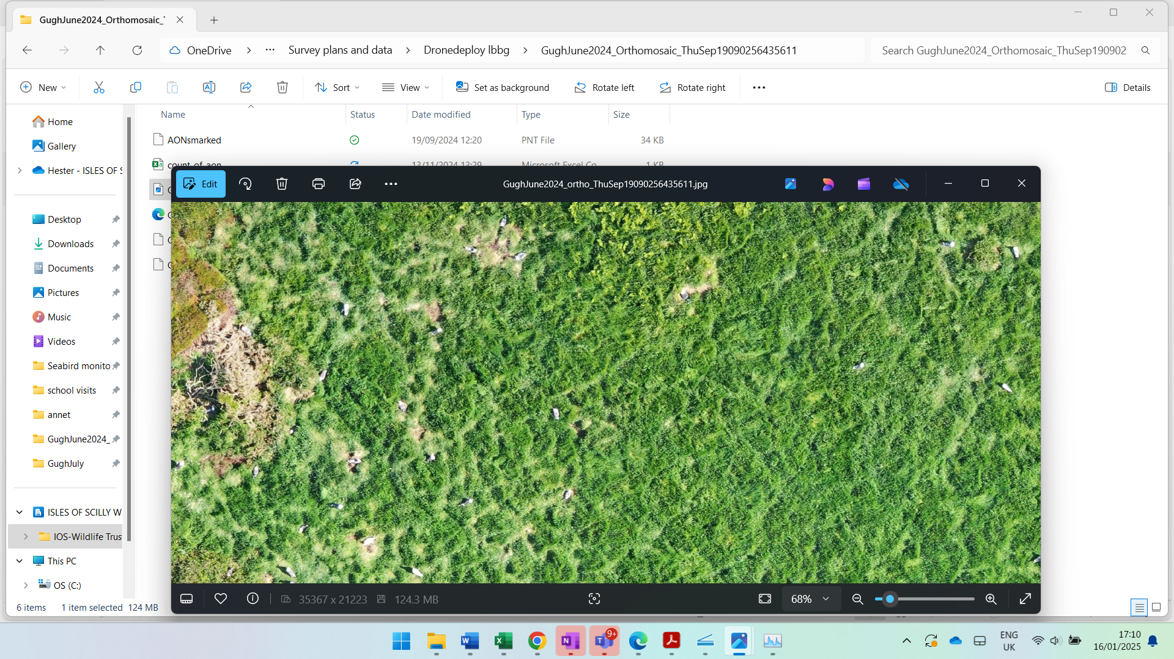

Figure 3. Example of an image from the drone survey

Drone footage has was used to estimate productivity at the Gugh colony in 2022 and 2024, in conjunction with an observer counting the total number of large chicks in the main colony in mid-July from a vantage point above the colony. In 2022 this method gave an estimate of 395 chicks from the 364 nests in the top sub-colony – a breeding success of 1.09 chicks per pair. Using the drone to identify chicks however, gave a significantly higher count again, of 493 chicks – 1.35 chicks per pair.

This method was repeated in 2024; the visual count gave 164 chicks and the drone survey gave 101 chicks. Using the higher of these two counts gives a productivity of 0.47 chicks per nest, the lowest recorded since 2018. It should be noted that the survey took place slightly later in the season than usual, possibly partially accounting for these low values due to some chicks already dispersing to the shoreline. In addition, the fact that the drone survey gave a significantly lower count suggests there may have been an issue with the analysis of the drone images.

**Manx shearwater**

Since the Seabird 2000 census in Scilly, breeding Manx shearwaters on Scilly have been surveyed using the diurnal tape playback census method, following the Seabird Monitoring Handbook (Walsh *et al*. 1995), to record the number of Apparently Occupied Burrows. This method uses a correction factor (ideally obtained from a site- and year-specific calibration survey) to take into account the number of birds that do not respond to the tape playback. In addition to inter-site variation, this response rate can show considerable annual variation.

Until 2019, a correction factor of 1.08 (based on a response rate of 0.93 as recommended in Newton (2004) was used in all Manx shearwater surveys on Scilly. As the Manx shearwater population increased over time since the removal of rats, it became possible to carry out a site-specific calibration survey on St Agnes. This was first done in 2021, in which a 5-day survey of 63 potentially occupied burrows (32 of which solicited at least 1 reply), which gave an average response rate of 0.63. Subsequent surveys in 2022 and 2023 gave average response rates of 0.49 and 0.32 respectively. The response rates were calculated by inputting response rate data into a *Shiny app* to implement a series of R scripts to calculate the average (Bolton, Padget & Wood *in prep*.) This average then gave the correction factor to be applied to the raw response date gathered during the survey across the full site. Due to limitations on both time and available burrows, the annual correction factor calculated for St Agnes has been applied to all Manx shearwater surveys carried out across Scilly during the year.

The wide range of average response rates calculated from St Agnes response rate in subsequent years suggests a high level of variability in this metric over time and across different sites. This should be taken into account when reviewing the corrected Manx shearwater survey results from sites across Scilly.

The 2024 response rate calibration study encompassed 47 apparently occupied burrows (28 of which solicited at least one reply), and gave an average response rate of 0.63, translating to a correction factor of 1.59. This is significantly lower than the 2023 correction factor of 3.13, which should be taken into account when looking at the apparent drop in Manx shearwater numbers since 2023. The 2024 Manx shearwater census obtained the highest recorded number of actual responses across St Agnes and Gugh, but due to this high response rate (and therefore low correction factor) the estimate of the number of Apparently Occupied sites is closer to levels seen in 2022.

Figure 4. Number of occupied Manx shearwater burrows (corrected) on St Agnes and Gugh

**Storm petrels**

Storm petrels were first recorded as a breeding bird to St Agnes & Gugh in 2015 following rat removal. Between 2015 and 2019 the number of breeding birds increased to approximately 20 pairs (apparently occupied sites) within the study plots on St Agnes and Gugh. An issue with predation by a cat from 2019 to 2022 resulted in large numbers of adults being predated at the three main breeding sites - Kittern Hill on Gugh, Burnt Island on St Agnes and at Troytown on St Agnes. A large number of adult birds were predated across these relatively wide-ranging sites (a minimum of 38 birds in 2019, 17 in 2021 and 4 in 2022 based on wings left behind). Following this, in 2022, the annual playback response survey elicited only one response on Gugh and none on St Agnes. The 2023 playback survey recorded 43 apparently occupied sites on St Agnes (40 on the Burnt Island colony) and 20 on Gugh. Surveys of the sample site on St Agnes (Burnt Island) produced 14 responses, equating to an estimate of 40 apparently occupied sites, indicating a steady population at this site since 2023.

As with Manx shearwaters, storm petrels on Scilly are surveyed using the diurnal call playback method, with a correction applied to take into account non-responding birds. Although the response varies between years and colony sites, the type and location of storm petrel nesting sites do not allow for a Scilly specific calibration survey. Therefore a correction factor of x2.86 (Ratcliffe *et al.* 1998 – response rate recorded by Robinson on Annet 1996 0.35 95% 0.252 LCI 0.448 UCI) is used for all storm petrel playback surveys across Scilly.

In preparation for the RSPB storm petrel tracking project carried out this summer, in late May a two person team from the RSPB used the following methods to survey all suitable habitat (boulder beaches, rock outcrops and drystone walls) on St Agnes and Gugh for nesting storm petrels:

1. Daytime walk-over searches with the detection dog
2. Daytime playback of recordings of storm petrel song to elicit responses from birds in occupied nest sites
3. Night-time visual searches using thermal imaging binoculars for birds flying over suitable habitat
4. Night-time walk-over searches to listen for birds singing from nesting crevices
5. Night-time playback of recordings of storm petrel song.

Results from this indicated the highest concentration of storm petrel nest sites was in the boulder beaches on Burnt Island. The only other location where birds were found was at Horse Point on St Agnes, where three closely-clustered points were each observed to hold at least two singing males. This distribution is in keeping with what had been previously found using the usual diurnal playback method.

As part of the RSPB storm petrel tracking project, 32 storm petrel nest boxes were installed on Burnt Island (see below Fig 5a & 5b) with the aim of encouraging birds to nest in more readily accessible sites. There was some evidence of prospecting birds entering nest boxes at the end of the season, and future surveys will show whether the increase in possible habitat represented by these boxes will result in any changes to the Burnt Island population.

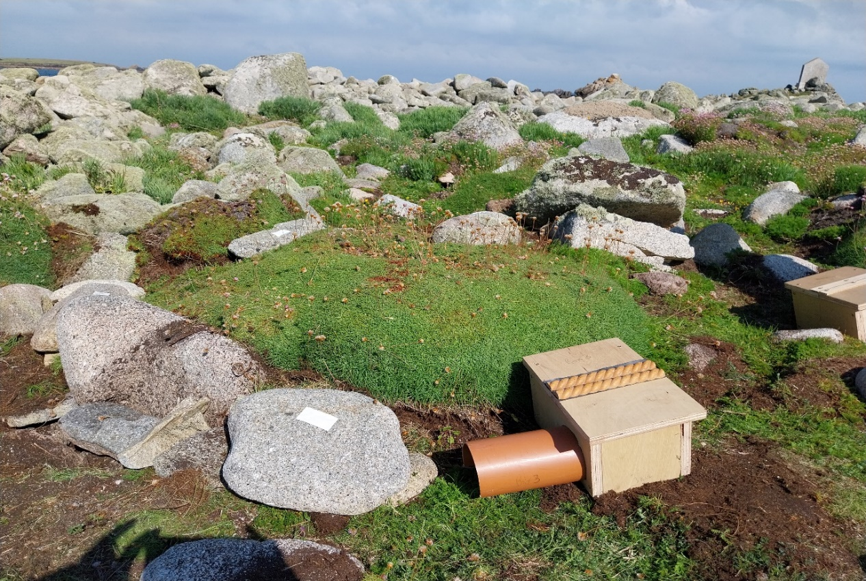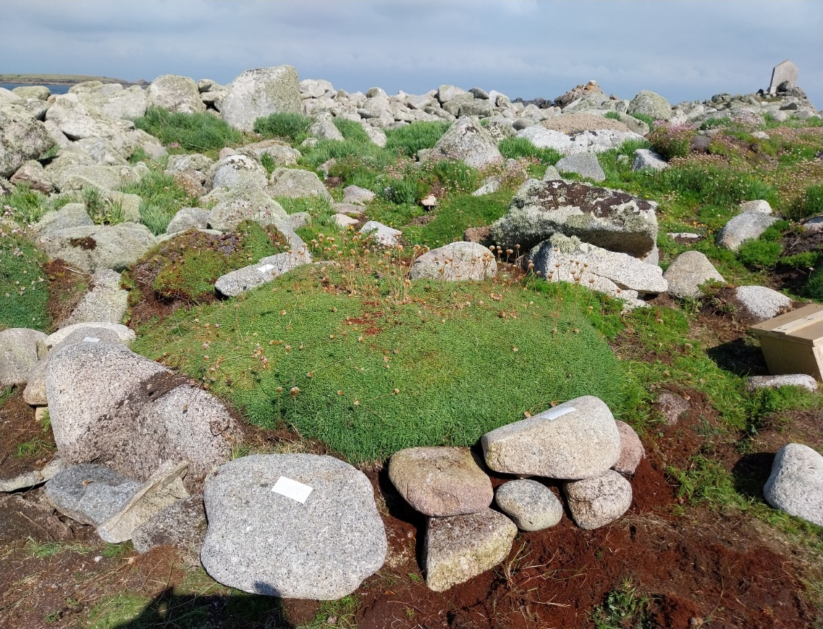

Figure 5a Storm petrel nest box before being buried Figure 5b. Storm petrel nest box once installed

credit: Mark Bolton

## Annual count of breeding seabirds on Annet

A count of the seabirds breeding on Annet has been made in most years since 2000 (see Table 3 – no counts were made in 2001, 2005 or 2020) through a land-based walkover survey, combined with boat-based surveys to count nesting fulmars and puffins. This year’s count shows an increase in the number of shags nesting on Annet, bucking the trend of consistent decline since 2021, although numbers are still well below the 200 recorded in 2000 (Fig. 7). Lesser black-backed gulls have increased slightly from the 5 pairs recorded in 2023, but the sub-colony that previously totalled 517 in 2000 remains deserted with the existing lesser black -backed gull nests found mainly individually along the coastline. The number of great black-backed gulls has continued to decline and is now at its lowest recorded total since 2008 (Fig. 6). Fulmars are also at their lowest since 2000.

Table 3. Breeding seabirds (pairs) on Annet *(SH – shag; GBBG – great black-backed gull; HG – herring gull; RAZ – razorbill; FUL – fulmar; COT – common tern; SP* - storm petrel; MX* – Manx shearwater; PUF – puffin; OYC – oystercatcher; RPL – ringed plover*

|  |  |  |  |  |  |  |  |  |  |  |  |  |
| --- | --- | --- | --- | --- | --- | --- | --- | --- | --- | --- | --- | --- |
| **Year** | **SH** | **GBBG** | **LBBG** | **HG** | **RAZ** | **FUL** | **COT** | **SP\*** | **MX\*** | **PUF** | **OYC** | **RPL** |
| **2000** | 209 | 137 | 517 | 42 | 4 | 21 | 1 | 938 | 123 | 47 | - | - |
| **2001** | - | - | - | - | - | - | - | - | - | - | - | - |
| **2002** | - | 171 | 215 | 7 | 4 | - | **-** | - | - | - | - | - |
| **2003** | 150 | 164 | 18 | 17 | 0 | 45 | 0 | - | - | - | - | - |
| **2004** | 159 | 197 | 7 | 32 | 2 | 44 | 0 | - | - | - | 5 | 0 |
| **2005** | - | - | - | - | - | - | - | - | - | - | - | - |
| **2006** | 177 | 187 | 281 | 24 | 4 | 37 | 0 | 788 | 89 | 50 | - | - |
| **2007** | 140 | 88 | 0 | 5 | 1 | 37 | 0 | - | - | - | 5 | 0 |
| **2008** | 164 | 47 | (5) | 4 | 3 | 48 | 0 | - | - | - | 6 | 0 |
| **2009** | 154 | 168 | 54 | 7 | 7 | 43 | 0 | - | - | - | 6 | 0 |
| **2010** | 198 | 213 | 76 | 11 | 2 | 40 | 0 | - | - | - | 7 | 1 |
| **2011** | 115 | 180 | 27 | 5 | 4 | 37 | 0 | - | - | - | 4 | 2 |
| **2012** | 107 | 177 | 32 | 8 | 2 | 49 | 0 | - | - | - | - | - |
| **2013** | 99 | 208 | 6 | 4 | 1 | 36 | 0 | - | - | - | 5 | 0 |
| **2014** | 96 | 205 | 10 | 5 | 1 | 38 | 0 | - | - | - | 9 | 1 |
| **2015** | 85 | 235 | 1 | 20 | 5 | 57 | 2 | 778 | 229 | 31 | 6 | 0 |
| **2016** | 86 | 215 | 1 | 16 | 6 | 41 | 14 | (106) | - | - | 4 | 1 |
| **2017** | 74 | 222 | 7 | 12 | 5 | 41 | 27 | (132) | - | - | 7 | 1 |
| **2018** | 81 | 170 | 6 | 19 | 0 | 46 | 0 | (175) | (30) | 43 | 8 | 0 |
| **2019** | 103 | 199 | 19 | 10 | 2 | 46 | 0 | (338) | (30) | 42 | 4 | 0 |
| **2020** | - | - | - | - | - | - | - | - | - | - | - | - |
| **2021** | 106 | 184 | 7 | 8 | 1 | 39 | 18 | - | (29) | 45 | 1 | 0 |
| **2022** | 98 | 188 | 5 | 17 | 4 | 37 | 0 | (132) | - | 36 | 11 | 0 |
| **2023** | 53 | 151 | 5 | 5 | 3 | 47 | 0 | n/a | n/a | 38 | - | - |
| **2024** | 88 | 138 | 18 | 10 | 4 | 30 | 11 | (29) | (26) | 34 | - | 0 |
| **\*Counts in brackets represent only a sample of the total breeding population on Annet** | | | | | | | | | | | | |

Figure 6. Number of great black-backed gull AON on Annet

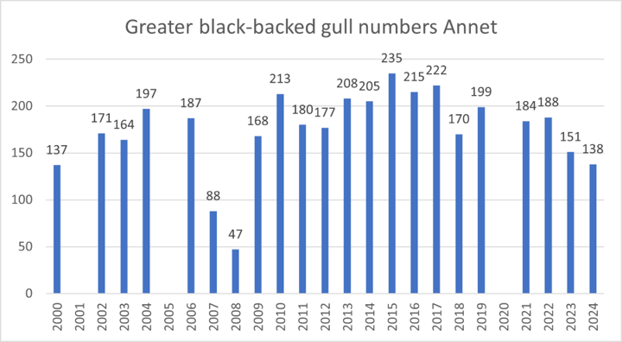

Figure 7. Number of shag AON on Annet

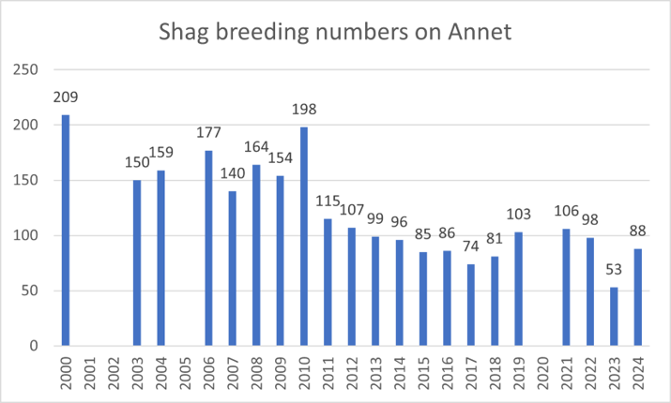

## Population monitoring work on Round Island & St Helen’s

**St Helen’s**

Following the St Helen’s Recovery Project carried out over the winter of 2023/24 (in which the population of rats was reduced to an estimated 5 individuals) the intention was to continue monitoring rat activity on a monthly basis via checks of the biosecurity grid to document the pattern of rat activity following the drastic reduction in the rat population during the project.

IOSWT staff did not ultimately have the capacity to do this over the seabird breeding season, however a check on 02/08/24 indicated that rat activity had expanded dramatically since the close of the St Helen’s Recovery Project, although there was still no evidence of rat activity in the areas nearest to the Manx shearwater colony on the North coast of the island.

A response survey of the St Helen’s Manx shearwater colony yielded 56 responses, which is corrected to 89 pairs once the correction factor obtained from St Agnes is applied. This constitutes a drop from the 2023 total of 115 pairs, largely due to the significant difference in the correction factors used in the different years (see previous section)

**Round Island**

A full playback survey for both Manx shearwaters and storm petrels was carried out across the whole of Round Island. Following the detection and subsequent clearance of a population of rats on Round Island in 2022 (Pearson 2022), rat presence was again detected in December 2023. A subsequent clearance effort over winter 2023/24 is thought to have succeeded, with no signs of rats detected on subsequent checks to date.

A full playback census of Manx shearwaters on the island solicited 45 responses, which is corrected to 62 with the 2024 correction factor applied. This constitutes a drop from (96) detected in 2023, although the low 2024 correction factor again accounts for this drop, as only 31 replies were solicited in 2023.

A full playback survey of storm petrels across the island on 29/06/2024 detected only 17 apparently occupied nests (6 responses multiplied by the 2.86 correction factor). This is a significant decline compared to the 105 pairs detected in the 2023 survey, suggesting that the presence of rats has adversely impacted the population. It is not known when the incursion first took place, and if it occurred while the 2023 breeding season was still in progress it may have resulted in predation of the birds and many adults abandoning the site, providing a possible explanation for the low 2024 count.

Table 4. Number of apparently occupied Storm Petrel nests on Round Island

|  |  |  |  |  |  |  |
| --- | --- | --- | --- | --- | --- | --- |
| **Island** | **2000** | **2006** | **2015** | **2022\*** | **2023** | **2024\*** |
| **Round Island** | 183 | 251 | 172 | 11 | 105 | 17 |
| **\*indicates a year rats are thought to have been present for at least part of the breeding season** | | | | | | |

## Productivity monitoring work across the archipelago

**Fulmar Productivity**

Since 2006 two of the main discrete cliff-side fulmar sub-colonies, those on Menawethan and the Daymark, St Martin’s, have been monitored from the sea. The numbers settling at the two sites have been relatively consistent, apart from a particularly high population count in 2023. The fledging success on Menathan and the Daymark has been quite variable (see Table 5), rising from 0.16 and 0.17 respectively in 2014 to a peak of 0.40 and 0.54 in 2021, then showing a decline across both sub-colonies, reaching a low of 0.11 and 0.18 this year. The recent productivity levels have been lower than the estimated average productivity of 0.5 chicks per pair per year that is needed for colony stability (Cook & Robinson 2010), possibly partly explaining the drop in breeding population of 16% since 2015 across Scilly.

Table 5. Productivity of fulmars nesting on Menawethan and the Daymark

|  |  |  |  |
| --- | --- | --- | --- |
|  | **Menawethan** | **Daymark** | **Total** |
| **2006** | **0.25 (*n* = 44)** | **0.20 (*n* = 46)** | **90** |
| **2007** | **0.30 (*n* = 41)** | **0.49 (*n* = 45)** | **86** |
| **2008** | **0.35 (*n* = 37)** | **0.28 (*n* = 46)** | **83** |
| **2009** | **0.43 (*n* = 33)** | **0.64 (*n* = 36)** | **69** |
| **2010** | **0.39 (*n* = 30)** | **0.45 (*n* = 51)** | **81** |
| **2011** | **0.29 (*n* = 24)** | **0.25 (*n* = 49)** | **73** |
| **2012** | **0.56 (*n* = 25)** | **0.39 (*n* = 59)** | **84** |
| **2013** | **0.52 (*n* = 27)** | **0.17 (*n* = 54)** | **81** |
| **2014** | **0.16 (*n* = 44)** | **0.17 (*n* = 52)** | **96** |
| **2015\*** | **(n = 43)** | **(n = 46)** | **89** |
| **2016** | **0.22 (*n* = 45)** | **0.19 (*n* = 57)** | **102** |
| **2017** | **0.24 (*n* = 34)** | **0.26 (*n* = 54)** | **98** |
| **2018** | **0.19 (*n* = 33)** | **0.34 (*n* = 50)** | **83** |
| **2019** | **0.53 (*n* = 34)** | **0.38 (*n* = 53)** | **87** |
| **2020\*** | **-** | **-** | **-** |
| **2021** | **0.40 (*n* = 43)** | **0.54 (*n* = 46)** | **87** |
| **2022** | **0.34 (*n* = 35)** | **0.45 (*n* = 51)** | **86** |
| **2023** | **0.17 (n=42)** | **0.36 (n=61)** | **103** |
| **2024** | **0.11 (n=55)** | **0.18 (n=27)** | **82** |

**\*Productivity not recorded in 2015 or 2020**

Figure 8. Productivity of fulmars nesting on Menawethan and the Daymark

**Herring gull settlement and productivity in Hugh Town**

Herring gull productivity in the Hugh Town colony remains reasonably stable, albeit with a slight drop to 1.35 chicks per nest in 2024 from 1.78 in 2023.

Figure 9. Herring Gull productivity in Hugh Town

In 2015 herring gulls were red-listed as a species of conservation concern due to recent declines in numbers nationally (estimated 47% loss of abundance, natural nesters only, 2000-2018, JNCC 2019). Breeding numbers of this species across Scilly have also been falling at a rapid rate with a decline of 40% between 2015 and 2023 to just 336 pairs. Starting in 2008 the productivity of herring gulls at three sub-colonies on St Mary’s, Tresco and Samson was recorded by observing minimum fledging success at mapped nests. St Mary’s is now the only colony monitored annually in this way due to the desertion of the Tresco colony in 2014 and the monitoring on Samson ceasing in 2022 due to difficulties in the terrain and the loss of the majority of the nesting pairs.

In 2024, the birds on St Mary’s fledged a minimum of 27 chicks from 20 nests. Over the years of this study the small roof-top colony in Hugh Town, which presumably relies on more anthropogenic food sources, has fared consistently better than the birds in natural colonies. With fledging success well above that needed for colony stability, the fact that the Hugh Town sub-colony has not increased beyond 20 pairs presumably reflects the limited amount of suitable undisturbed roof space available.

## Camera monitoring

This year, funding from the Natural England mNCEA programme allowed us to expand the use of trail cameras in our monitoring program. This was done with the aim of collecting data on productivity and provisioning for some of the highest priority breeding species on Scilly, in accordance with the suggestions from Natural England as part of Scilly’s position as a proposed SMP key site for England. The following cameras were deployed on breeding colonies across Scilly:

* 3 trail cameras on Gugh LBBG colony
* 2 fixed Cameras on GBBG colony on Annet
* 1 trail camera on Gugh Kittiwake colony
* 3 trail camera on Shag nests on Annet and St Helen’s

This data has been sent to Natural England, to be shared through Dr Tom Hart (Oxford Brookes) with SeabirdWatch (www.seabirdwatch.org) on the Zooniverse Citizen Science platform to see what useful data can be extracted from it. Unfortunately due to a combination of issues with setup, bird behaviour and technical failure it is likely that a lot of the images collected will not be appropriate for useful analysis.

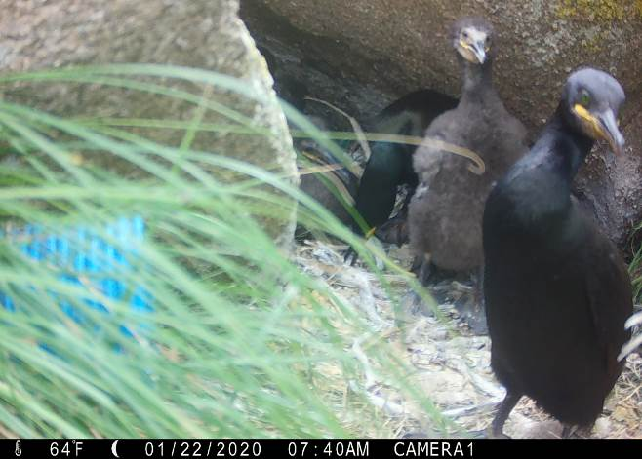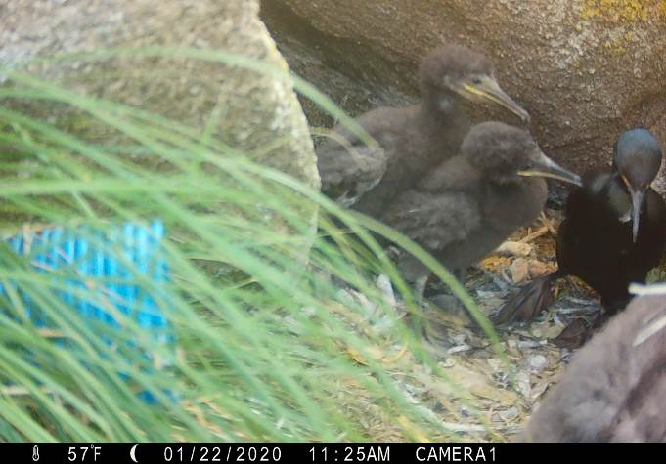

Figure 10. Photos from Annet shag nest camera

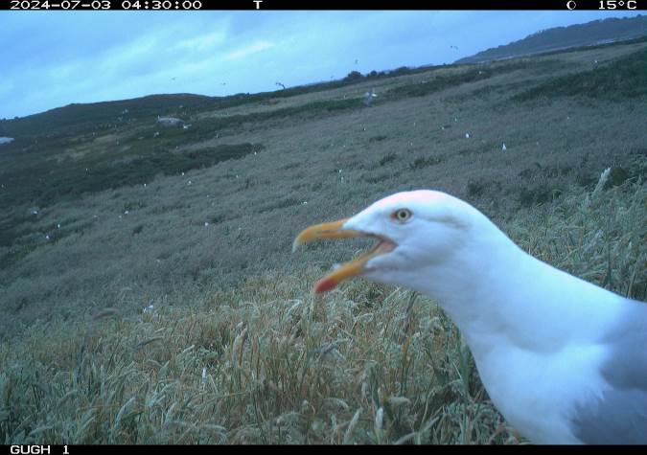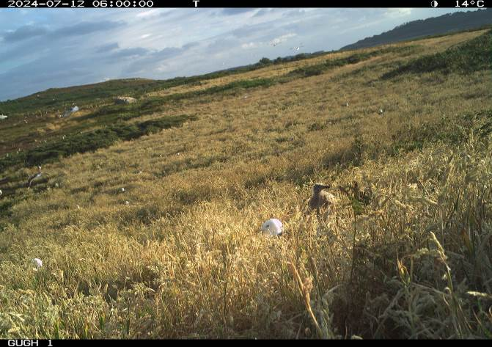

Figure 11. Photos from Gugh lesser black-backed gull nest camera

Following a consultation with Tom Hart, a series of recommendations were made to improve our deployment of cameras next summer, including:

* Repositioning the cameras previously deployed on the Annet great blacked-gull colony to monitor the fulmars nesting on Annet.
* Deploying all cameras earlier in the season and bringing them in later
* Using improved tripods/ vantage points to obtain images from a greater height and angle
* Setting the cameras to take images at longer time intervals

## Seabird Ringing

With the support of IoS Wildlife Trust, NE, RSPB, West Cornwall Ringing Group (WCRG), University of Exeter and Jim Askins, ringing work was undertaken in six periods in 2024:

* Early breeding season colour-ringing (and GPS tag deployment) of adult shag and lesser black-backed gull, on 22nd May to 1st June (UoE - Annet, Samson, Gugh, St Helens)
* Mid breeding season colour ringing of shag, lesser black-backed and great black-backed gull chicks on 25th to 27th June (WCRG & IoSWT - Annet, Rosevear, Gugh)
* Mid breeding season colour ringing of lesser black-backed gull chicks on 12th July (WCRG & IoSWT - Gugh)
* GPS tracking of storm petrels on 12th July to 9th August (RSPB - Burnt Island)
* Late breeding season ringing of adult Manx shearwater on 10th to 11th August (WCRG & IoSWT - St Agnes, Gugh)
* Late breeding season ringing of Manx shearwater chicks and storm petrels on 30th August to 1st September (NE, WCRG & IoSWT - St Agnes, Gugh, Annet)

Totals of birds ringed over the course of the season are found in Table 6.

|  |  |  |  |
| --- | --- | --- | --- |
| **Species** | **Age Class** | **Number Ringed** | **Number Colour Ringed** |
| Shag | Adult | 18 | 16 |
| Chick | 107 | 107 |
| Great Black-Backed Gull | Adult | 2 | 2 |
| Chick | 41 | 38 |
| Lesser Black-backed Gull | Adult | 15 | 15 |
| Chick | 49 | 47 |
| Herring Gull | Adult | 4 | 3 |
| Chick | - | - |
| Manx Shearwater | Adult | 40 | - |
| Chick | 38 | - |
| Storm Petrel | Adult | 98 | - |
| Chick | 4 | - |

Table 6. Seabirds ringed on Scilly in 2024 as part of the Scillonia ringing group

In addition, Jim Askins has led the re-started project of ringing storm petrel and Manx shearwater on St. Mary’s.

# Acknowledgements

IOS National Landscape

This project was part-funded by the Department for the Environment, Food and Rural Affairs (Defra) as part of the marine Natural Capital and Ecosystem Assessment (mNCEA) programme.

West Cornwall Ringing Group

St Agnes Boating

Volunteers from Scilly including Maddie Kirby, Adam , Trish Payne

IOSWT staff – Helen Miller, Jacob Blackett, Sarita Whitehead, Meg Lloyd and the whole ranger team

RSPB staff including Jaclyn Pearson and Paul St Pierre and all staff who came out to Scilly on sabbaticals

Troytown Campsite

Gareth Tibbs

Natural England staff including Justin Hart, Bart Donato and Becky Hodgkiss

References

Bolton M, Padget O & Wood M J. Review methods and guidance on survey design and data analysis to estimate population size for burrowing nocturnal seabirds.

Booker H, Price D, Slader P, Frayling T, Williams T & Bolton M (2019) Seabird recovery on Lundy: Population change in Manx shearwaters and other seabirds in response to the eradication of rats. British Birds 112: 217-230.

Brisson-Curadeau E, Bird D, Burke C, Fifield DA, Pace P, Sherley RB & Elliott KH (2017) Seabird species vary in behavioural response to drone census. Scientific Reports, 7, 17884.

Brooke M (1990) The Manx shearwater. Poyser, London.

Cook ASCP & Robinson RA (2010) How representative is the current monitoring of breeding success in the UK? BTO Research Report No.53, BTO, Thetford.

Heaney V & St Pierre P (2017) The status of seabirds breeding in the Isles of Scilly in 2015/16. Upubl. RSPB Report.

Furness, RW & Greenwood JJD (1993) Birds as monitors of environmental change. London, UK: Chapman & Hall.

Heaney V (2017) Seabird Technical Report 2017 – Seabird monitoring and research project Isles of Scilly 2013-2017. Unpubl. Seabird Recovery Project Report.

JNCC (2019) Seabird Population Trends and Causes of Change: 1986–2019 Report [https://jncc.gov.uk/our-work/smp-report-1986-2019/] Joint Nature Conservation Committee.

Newton, S.F., Thompson, K. & Mitchell, P.I. 2004. Manx Shearwater *Puffinus puffinus*. In Mitchell, P.I., Newton, S.F., Ratcliffe, N. & Dunn, T.E. (eds.), Seabird Populations of Britain and Ireland, 63–80. T & AD Poyser, London

Pearson J (2022) Biosecurity for Life - Rodent Presence/ absence Reporting January – March 2022. RSPB Report.

Ratcliffe N, Vaughan D, Whyte C & Shepherd M (1998) Development of playback census methods for Storm Petrels *Hydrobates pelagicus*. Bird Study 45:3, 302-312.

Rush GP, Clarke LE, Stone & Wood MJ (2018) Can drones count gulls? Minimal disturbance and semiautomated image processing with an unmanned aerial vehicle for colony-nesting seabirds. Ecology and Evolution 2018:1–13.

Seabird Group (2021) Newsletter 148, October 2021. The Seabird Group.

Walsh PM, Halley DJ, Harris MP, del Nevo A, Sim IMW & Tasker MC (1995) *Seabird monitoring handbook for Britain and Ireland*. JNCC / RSPB / ITE / Seabird Group, Peterborough.

APPENDIX 1. A short report on Ringing and Colour Ringing for the Isles of Scilly Seabird Recovery meeting – Oct 2024

Bart Donato

**Background**

Natural England (NE) is concerned that high quality demographic monitoring of seabirds in England is currently insufficient. This is especially so away from the North Sea, which is partly covered by Scottish species monitoring, so NE seeks to improve data collection from key sites with a view to elevating sites, where possible, to proxy-Seabird Monitoring Programme (SMP) data grade. The focal species will vary from site to site depending on accessibility, logistics and population size.

Within this the Isles of Scilly is seen as being a key site in England’s network of Seabird sites, both for the representative species it hosts and its position as a Celtic Sea seabird site. A key need with SMP sites is to have individually identifiable birds to enable demographic data collection, which is best achieved by having ringed birds. The aspiration is to establish marked populations that in time will support at least a Re-trapping Adults for Survival (RAS) grade study, while also supporting individual species based longitudinal studies that are more academic-research led. To this end NE secured funding from Defra’s Marine Natural Capital and Ecosystem Assessment (mNCEA) Programme to support 2024 as a seabird ringing pilot study season that will inform future plans.

In the Isles of Scilly key species include tubenoses; Puffin; Shag; Lesser Black-backed and Great Black-backed Gulls. Of these the latter three species lend themselves to colour ringing based studies as they are relatively accessible and likely to generate informative re-sightings. The Puffin population is currently difficult to access and is considered highly sensitive, however, it is also the subject of research studies lead by the University of Exeter. With the University also researching diet of Shag and Lesser Black-backed Gull this also affords the opportunity to streamline effort and maximise data value. Due to their habits the tubenoses would normally be considered less likely to offer a high resighting rate, however, the programme of pelagic trips around the IoS may make the IoS an exception.

As a result, the ambition for 2024 was to establish a colour-marked population of Shag, Great Black-backed Gull and Lesser Black-backed Gull within the islands. New colour ring schemes have been established for Shag and Puffin, and schemes for Great-backed Gull, Lesser Black-backed and Herring Gull have been extended from mainland Cornwall with the support of the West Cornwall Ringing Group.

The second aim of the 2024 work was to establish the resource requirements and logistics required to deliver an annual seabird ringing programme.

A code of conduct for community relations on all sites was written and adhered to. This included wearing uniform brightly coloured hats to identify the team in seabird colonies, a nominated spokesperson to talk to passers-by and any nearby local community members. When camping on uninhabited islands this included informing the coastguard and providing information to boating companies and local communities on the purpose of the trips and outcomes. Added to this, in September St Mary’s local ringers collected and ringed Manx shearwaters which become stranded on St Mary's (this happens each year as they are distracted by the lights, particularly on the quay). This was well received by the local community, as ringing these individuals added value to the effort of the residents in reporting them, and raised awareness on light pollution.

**Outcomes**

To deliver the programme, the Scillionia Seabird Group has been re-established allowing a centralised ringing programme to be operated and to ensure coordination of activity and reporting.

With the support of IoS Wildlife Trust, NE, RSPB, West Cornwall Ringing Group, University of Exeter and Jim Askins, ringing work was undertaken in six periods in 2024:

* Early breeding season colour-ringing (and GPS tag deployment) of adult Shag and Lesser Black-backed Gull, between 22 May and 1 June (UoE - Annet, Samson, Gugh, St Helens)
* Mid breeding season colour ringing of Shag, Lesser Black-backed and Great Black-backed Gull chicks on 25-27 June (WCRG, IoSWT - Annet, Rosevear, Gugh)
* Mid breeding season colour ringing of Lesser Black-backed Gull chicks on 12 July (WCRG, IoSWT - Gugh)
* GPS tracking of Storm Petrels between 12 July and 9 August (RSPB - Burnt Island)
* Late breeding season ringing of adult Manx Shearwater on 10-11 August (WCRG, IoSWT - St Agnes, Gugh)
* Late breeding season ringing of Manx Shearwater chicks and Storm Petrels on 30 August to 1

September (NE, WCRG, IoSWT - St Agnes, Gugh, Annet)

Over the course of the season totals of birds ringed were:

|  |  |  |  |
| --- | --- | --- | --- |
| **Species** | **Age Class** | **Number Ringed** | **Number Colour Ringed** |
| Shag | Adult | 18 | 16 |
| Chick | 107 | 107 |
| Great Black-Backed Gull | Adult | 2 | 2 |
| Chick | 41 | 38 |
| Lesser Black-backed Gull | Adult | 15 | 15 |
| Chick | 49 | 47 |
| Herring Gull | Adult | 4 | 3 |
| Chick | - | - |
| Manx Shearwater | Adult | 40 | - |
| Chick | 38 | - |
| Storm Petrel | Adult | 98 | - |
| Chick | 4 | - |

In addition, a programme of Storm Petrel and Manx Shearwater ringing has been re-started, led by Jim Askins, based on St. Mary’s which will complement the other work.

Although the work is aimed at enabling the collection of demographic data, which will be a long-term outcome, it has already yielded some interesting movement data including:

* Storm Petrel ringed on St Mary’s recaught three hours later at Porthgwarra, Cornwall
* Four French-ringed Storm Petrels recaught on Annet on the same night
* Colour-ringed Shag chick from Rosevear seen in Brittany in September (see map)
* Nine Lesser Black-backed Gulls (five adults and four juveniles) seen in Iberia, including one bird seen on the coast, later relocating to an inland landfill site (below)
* Two Lesser Black-backed Gulls seen from pelagic trips aboard the Sapphire also later seen in Iberia

Critically the work in 2024 has shown that the establishment of a co-ordinated seabird ringing and monitoring programme in the IoS is feasible and has identified priority areas to invest in to support the development of a long-term programme.

**Plans for 2025**

Subject to securing funding, NE hopes to be able to continue to support the development of the programme in 2025 it is hoped that this will include:

● a consolidated programme based on this year’s ringing programme focusing on the same core species suite

● further development of on-island seabird ringing capacity though trainee ringer support

● development of an online reporting platform working with West Cornwall Ringing Group

In addition, the likely value of establishing a colour ringing programme for Storm Petrel is being assessed