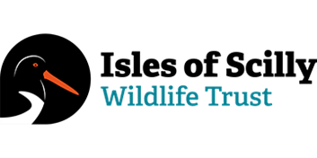
Confidential
APPLICATION FORM; TRUSTEE

Please send in this form to jobs@ios-wildlifetrust.org.uk

Personal details
Surname | First name
Address:

Postcode

Home | Mobile
E mail address:

Current or most recent job(s):
Employer’s name and address | Position held & dates

Criminal record:
Have you ever been convicted of a criminal offence? Yes/no (delete as applicable)

If yes, please give details of any unspent criminal offences in accordance with the Rehabilitation of Offenders Act (Exceptions) Order 1975 and/or (Northern Ireland) 1979:

What can you bring to the Board of the Isles of Scilly Wildlife Trust?
{please continue another page if necessary}

